AIRFOOD USER MANUAL 

Table of Contents

1. About Airfood system 2

2. Beneficial’s of Airfood 2

3. System requirements 2

4. Exploring the login page 2

5. Registering a user 3

6. profile after registering 5

7. Booking a One way trip 7

Meal ordering 8

8. Booking a round trip 11

Meal ordering 12

9. Payment 16

10. Admin roles 17

All users 17

Non verified users 18

Verified users 18

Filtering by date 19

Filtering by name 19

View flight bookings 20

# About Airfood system

It is a system for booking airplane tickets with the capability of paying online. It allows you to order food via the system. The food ordered is delivered to the passenger where they are seated.

Airfood is synonymous system with innovation and convenience as well as a full tummy of course. You need a quick and effortless way to book? Do not worry, we have your back. The safety and comfort of our guests is of utmost importance to us. We endeavour to always keep our guess happy by offering pleasant flights at affordable rates.

# Beneficial’s of Airfood

* Sole proprietors, commission earners
* Airports
* Administrator
* Passengers

# System requirements

* Smart Phone
* Computer/Laptop
* Internet browser

# Exploring the login page

Clicking **“LOGIN”**, allows the user to login if the user has already registered.

Clicking **“Sign up here”**, allows a guest user to register an account.

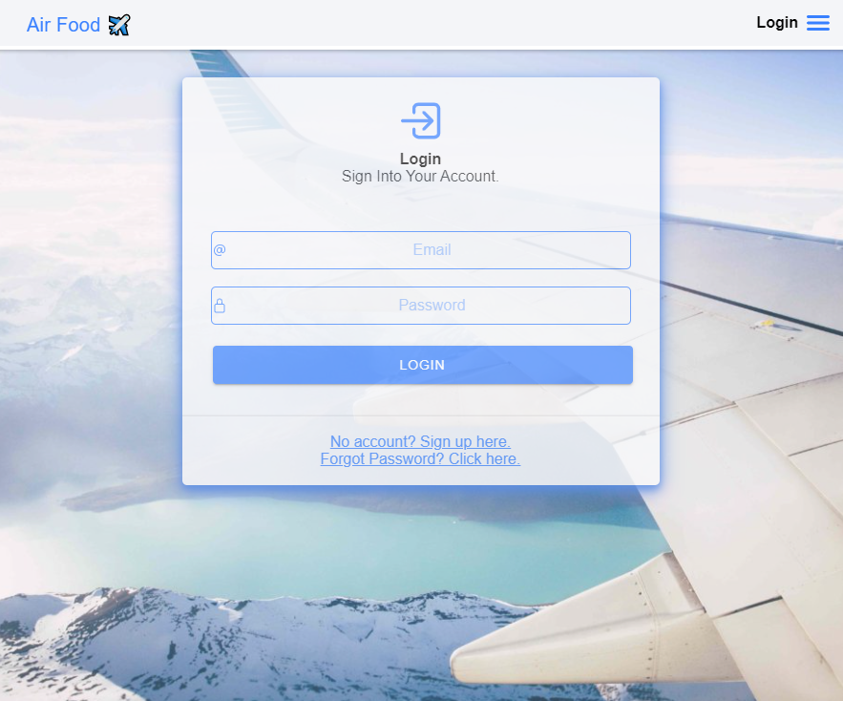

# Registering a user

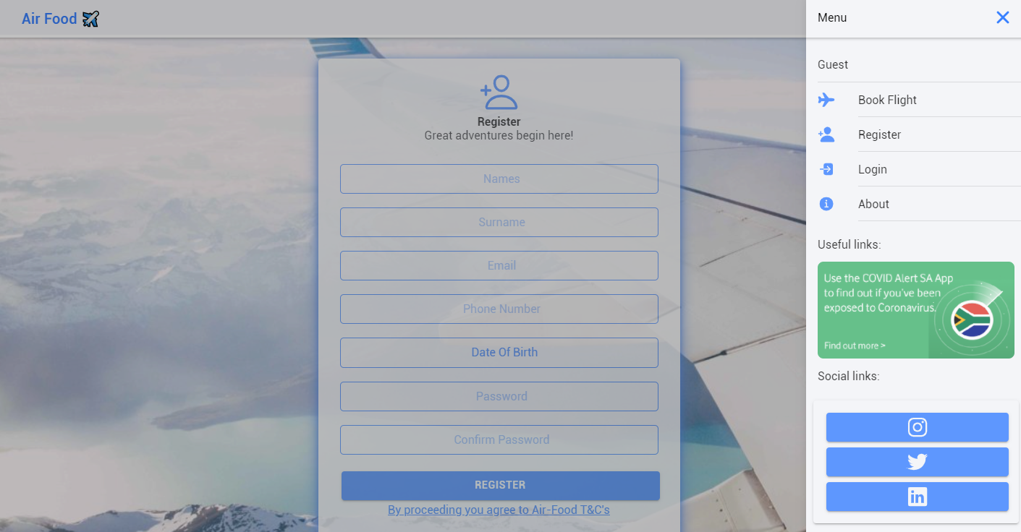

To get user registered do the following:

* Register with your email address.
* Fill in your name, last name and date of birth.
* Create password.
* Password should be the same on confirmation.
* Password must contain more than 8 characters (Must contain at least one uppercase, one lowercase, a number and one special character.
* Click register to proceed.
* Verification email will be sent to your existing email.

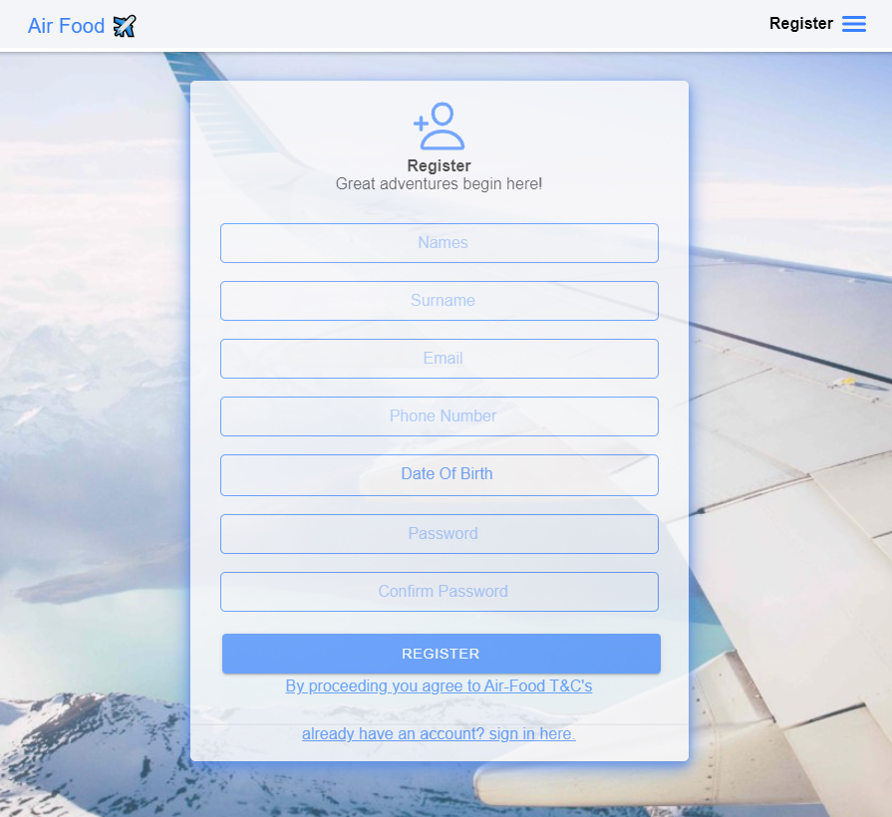

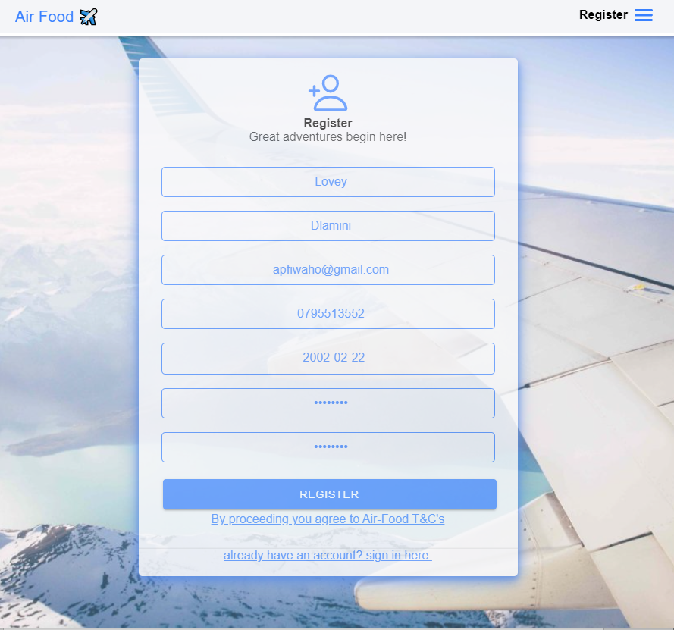

# profile after registering

Clickon “**Profile**” tab to make changes.

* Update name, surname, phone number on the text boxes.
* Click on “**DEACTIVATE** **ACCOUNT**” to deactivate your account.
* Click on “**DELETE** **ACCOUNT**” to permanently remove your account.
* Add details like your gender and province

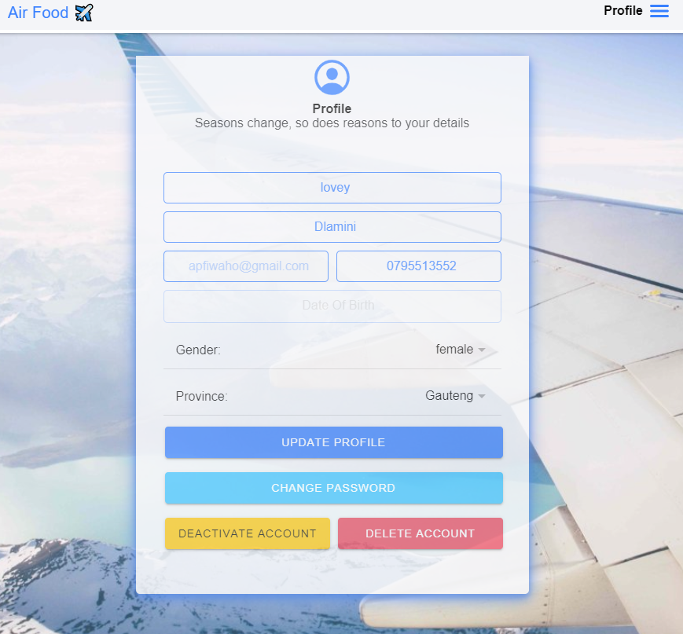

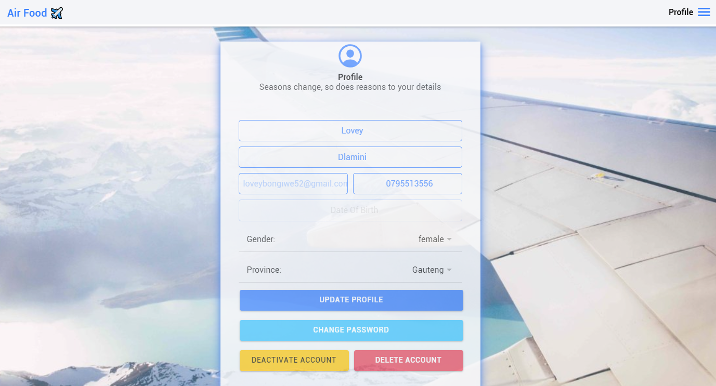

# Booking a One way trip

* Choose return or one way.
* This is for a one way
* Choose the destination.
* Choose your departure date
* Indicate the number of adults and children

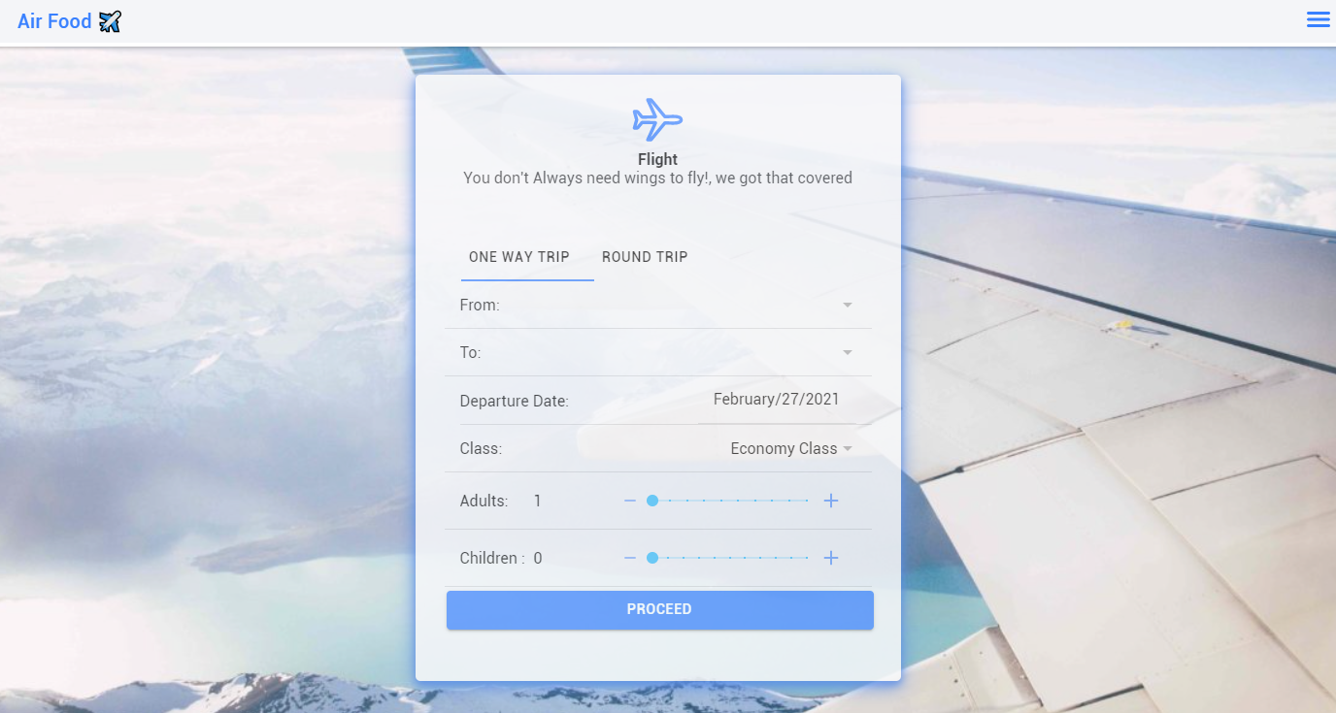

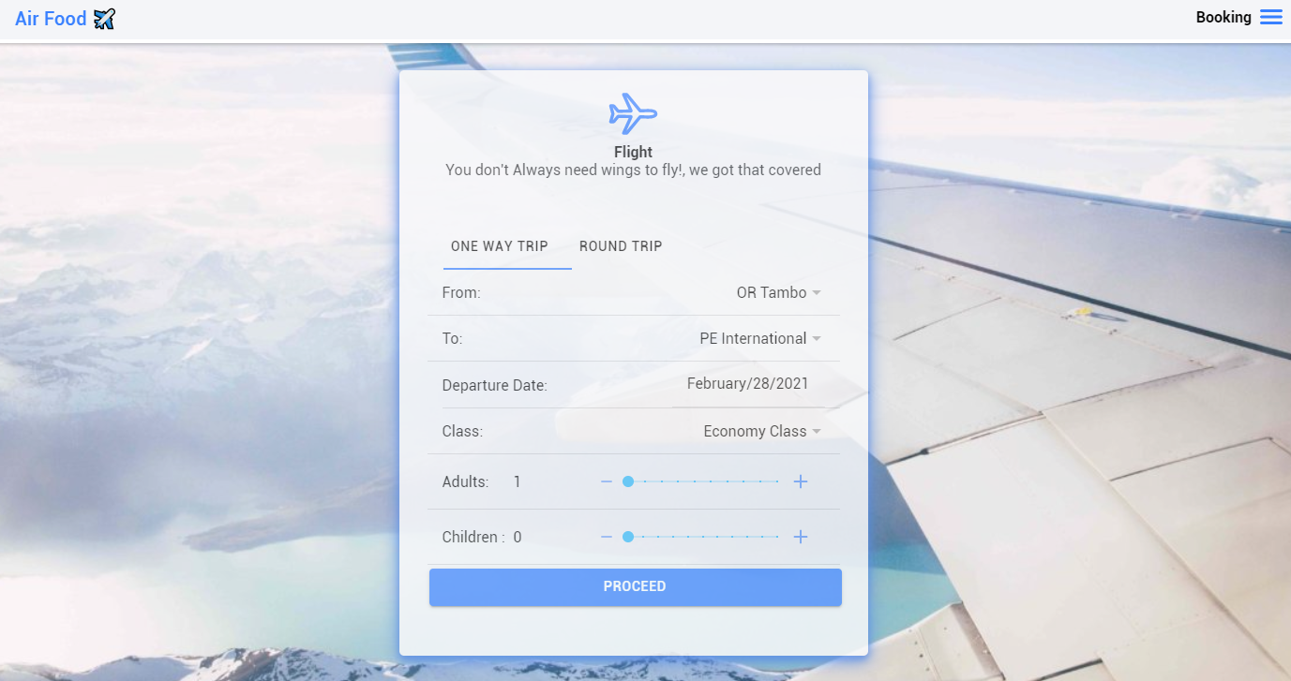

Shows available flights for the choosen date

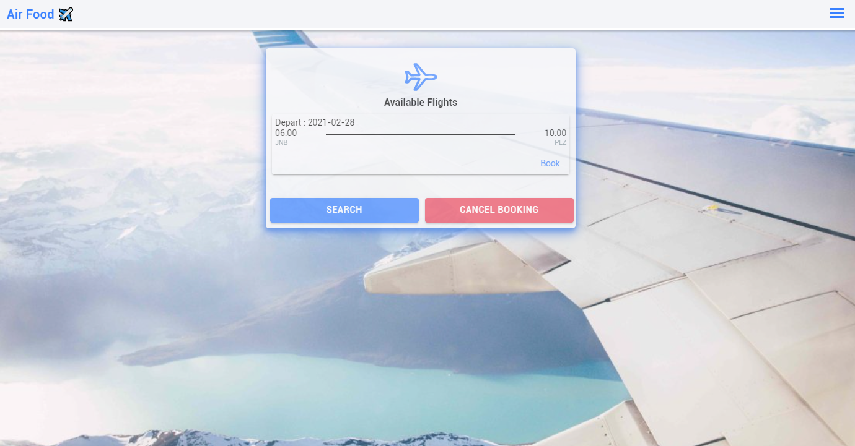

## Meal ordering

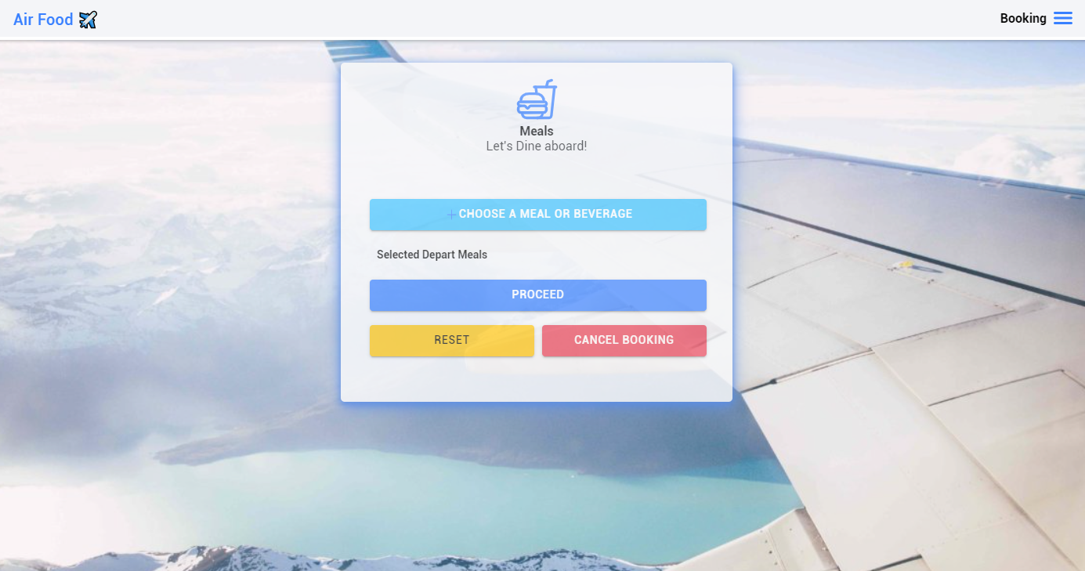

* Click on “**CHOOSE** **A MEAL OR BEVERAGE**” to add a meal on your booking ticket.
* Click on “**RESET**” to cancel meal(s) chosen.
* Click on “**PROCEED**” to continue.

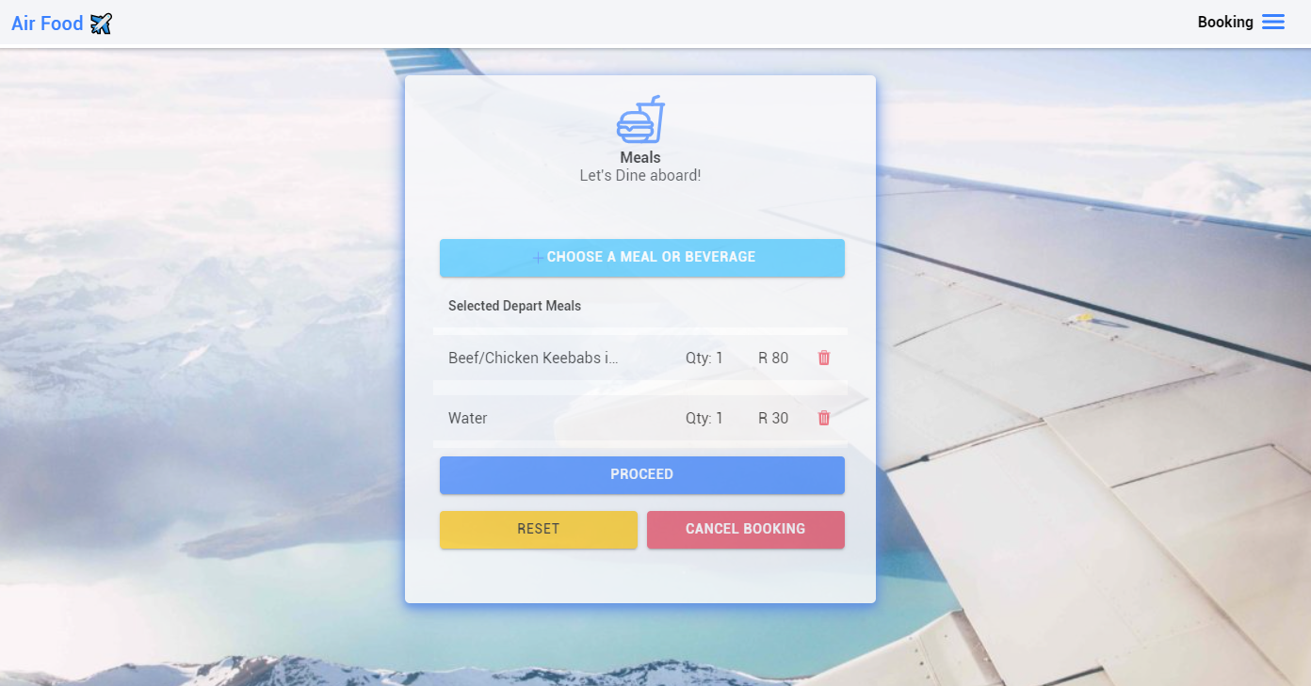

The booking details are displayed before proceeding to payment.

* You can click “**CONFIRM** **AND** **BOOK**” to proceed to payment.
* You can click “**CANCEL** **BOOKING**” to cancel the flight booking.

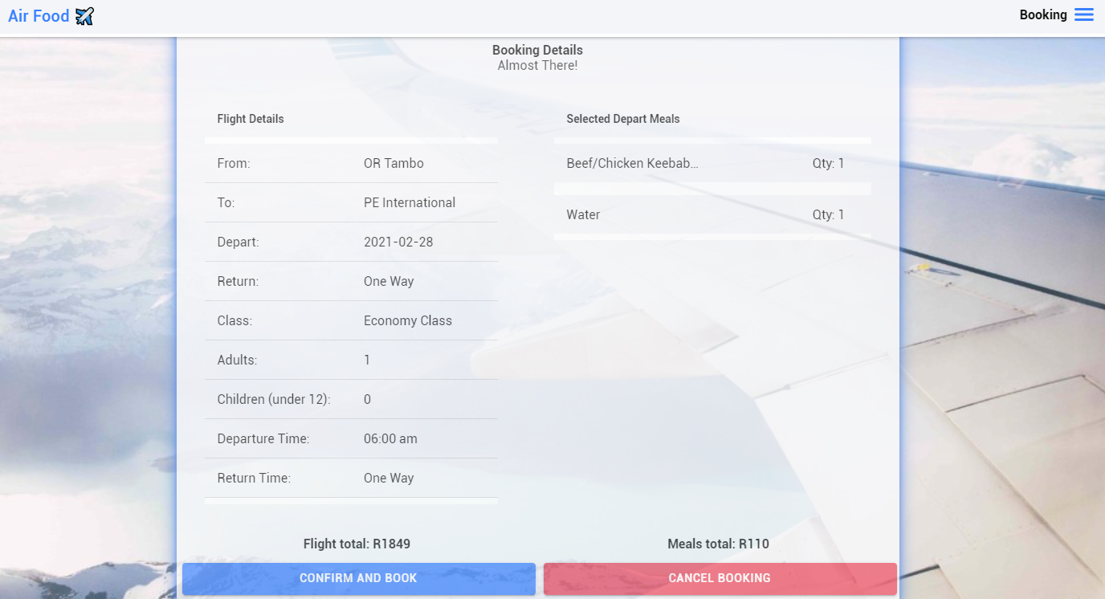

All tickets booked are displayed

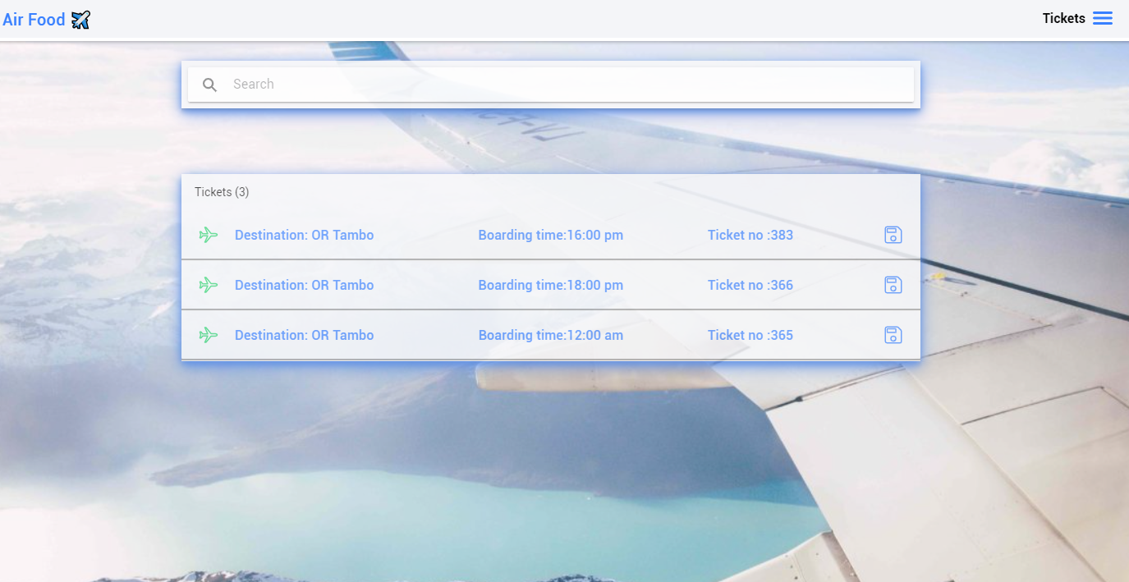

When the payment has been accepted, the final ticket is displayed

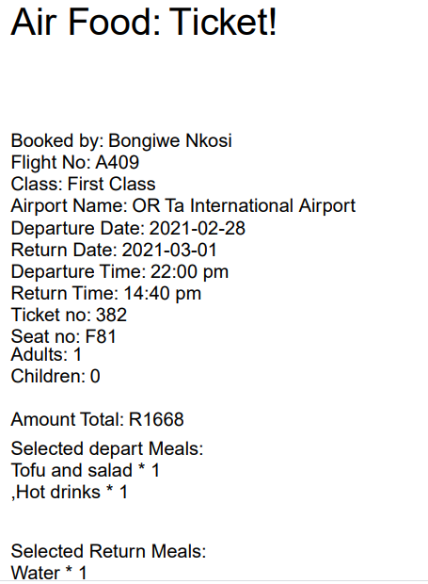

# Booking a round trip

Choose return or one way.

This is for a round trip

Choose the departure time and date

Choose your return time and date

Indicate the number of Adults and children.

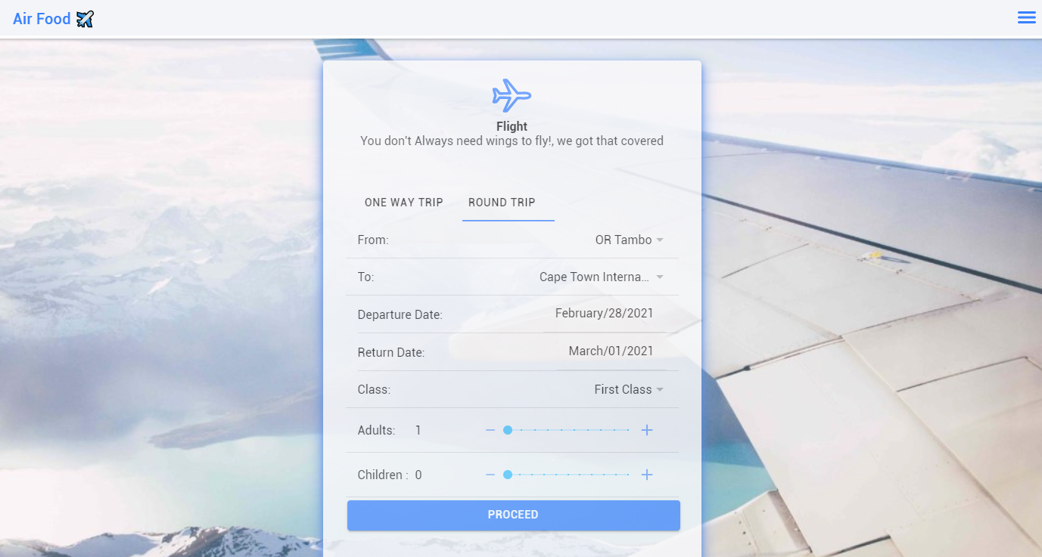

All available flights will be displayed on the following page

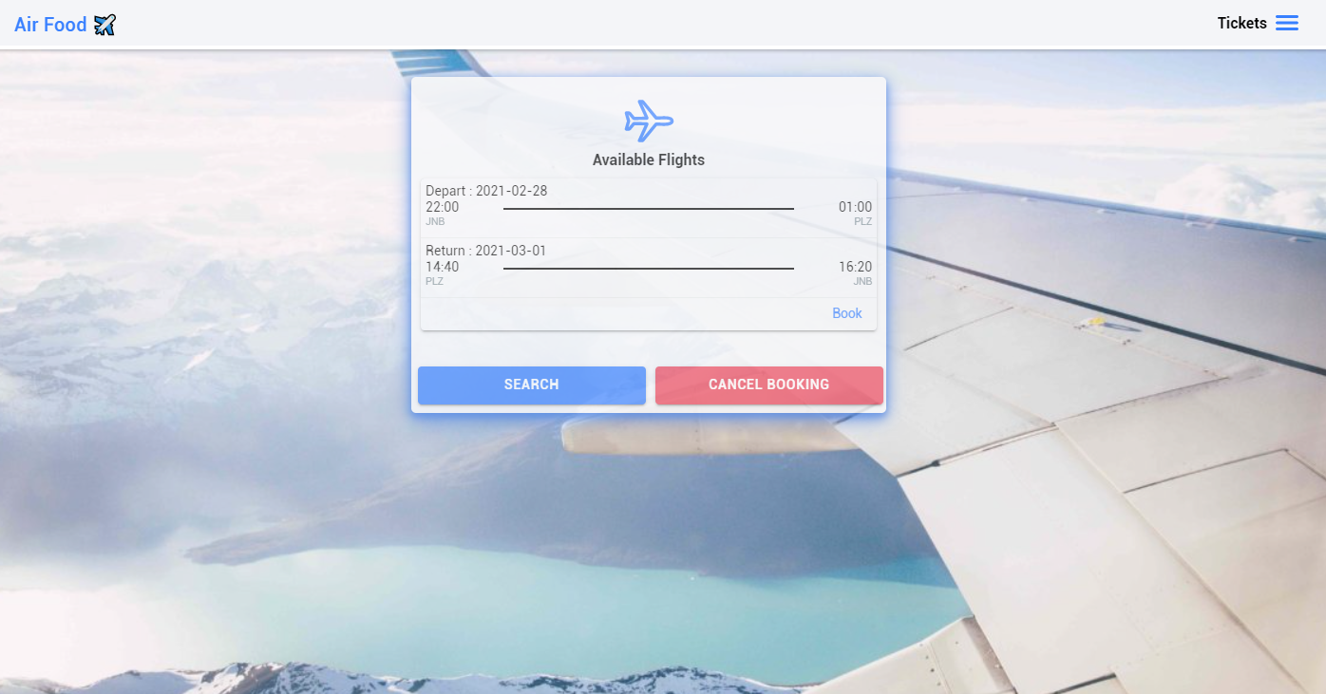

## Meal ordering

* Click on “**CHOOSE** **A MEAL OR BEVERAGE**” to add a meal on your booking ticket.
* You can choose for both trips
* Click on “**RESET**” to cancel meal(s) chosen.
* Click on “**PROCEED**” to continue.

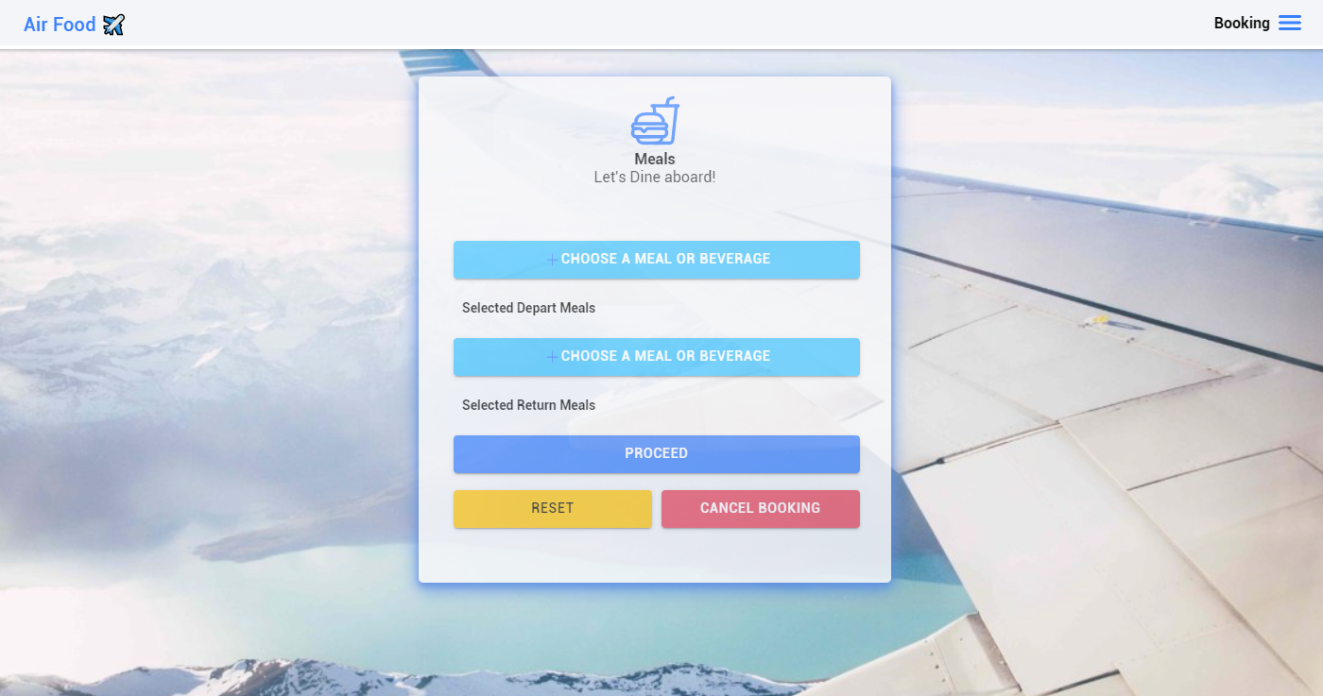

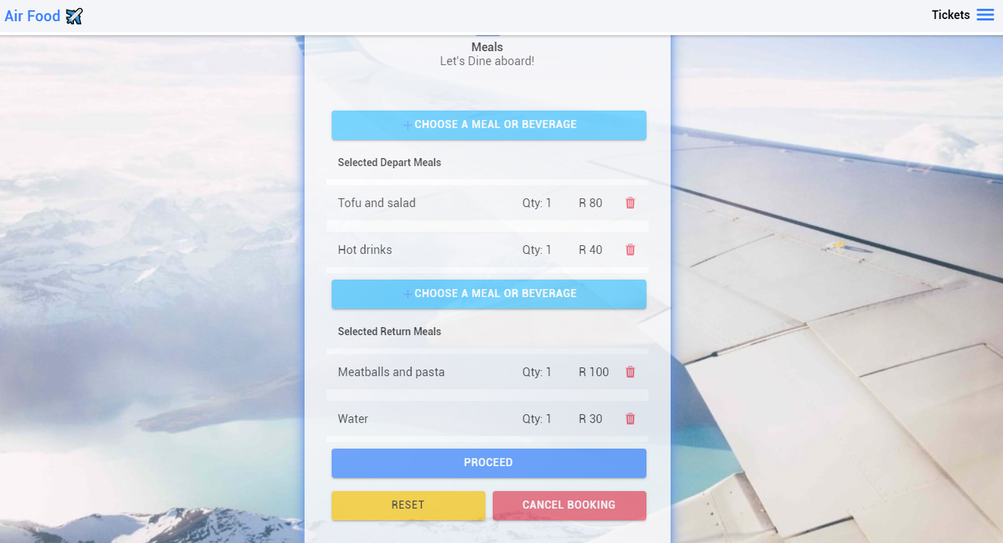

The booking details are displayed before proceeding to payment.

* You can click “**CONFIRM** **AND** **BOOK**” to proceed to payment.
* You can click “**CANCEL** **BOOKING**” to cancel the flight booking.

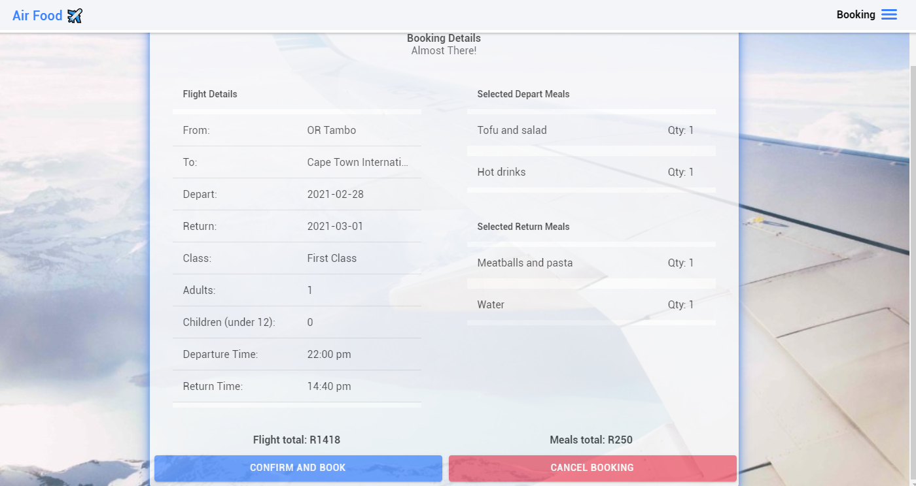

* All tickets booked are displayed
* You can search your ticket if you have booked more than one ticket.

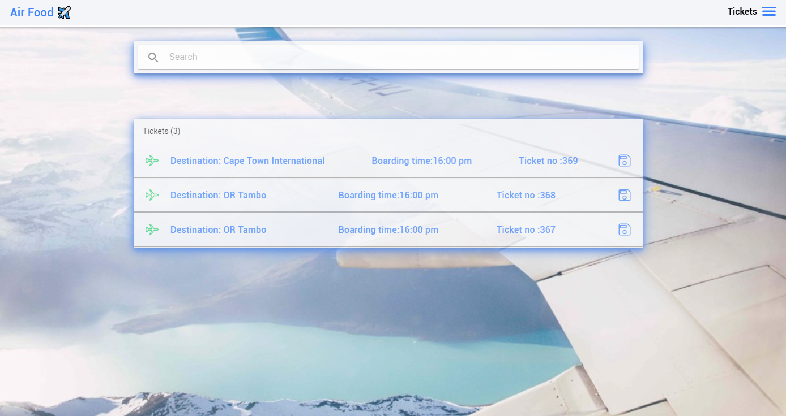

When the payment has been accepted, the final ticket is displayed

**\**

# Payment

The payment system accepts:

* Mastercard
* Maestro
* Visa

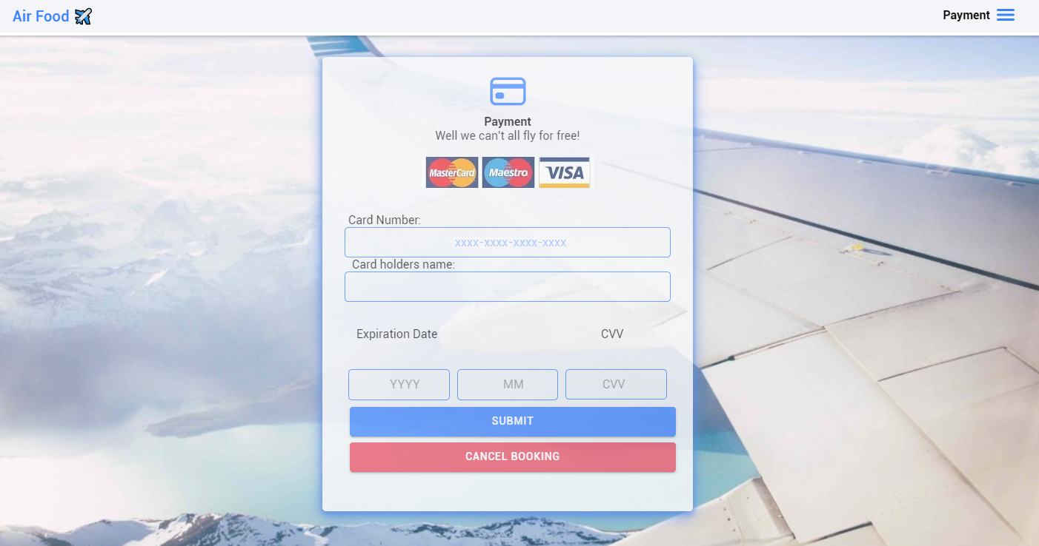

* Click on “**SUBMIT**” to book and purchase the ticket.
* Upon successful payment verification, a success status will be displayed.
* You will be redirected to the ticket’s form page.

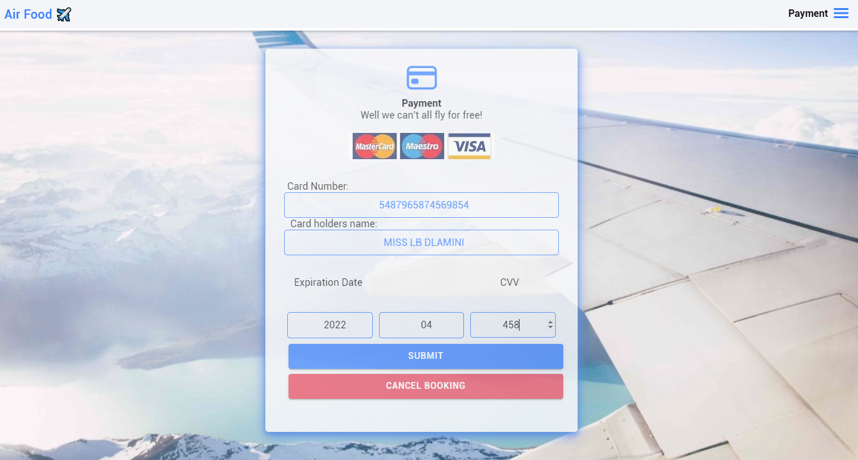

# Admin roles

* Check user profiles.
* Update his or her profile.
* View the number of tickets booked.
* Register a normal user or an admin user.
* Download all the users logs in csv, xlsx, pdf or json format.
* Delete a user.
* Check the bookings of the users.

The admin can view verified, non-verified and all users.

## All users

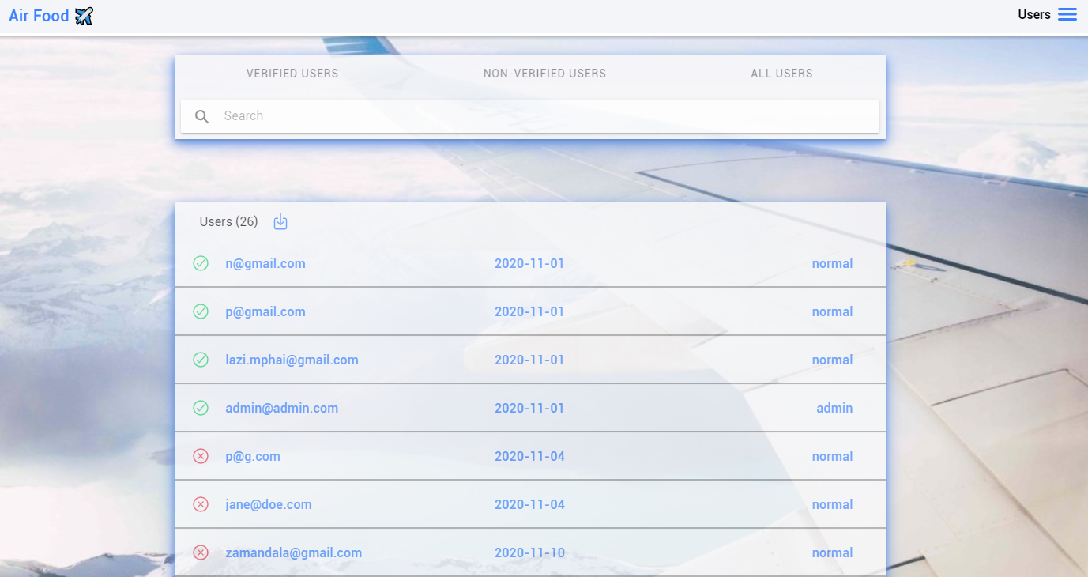

## Non verified users

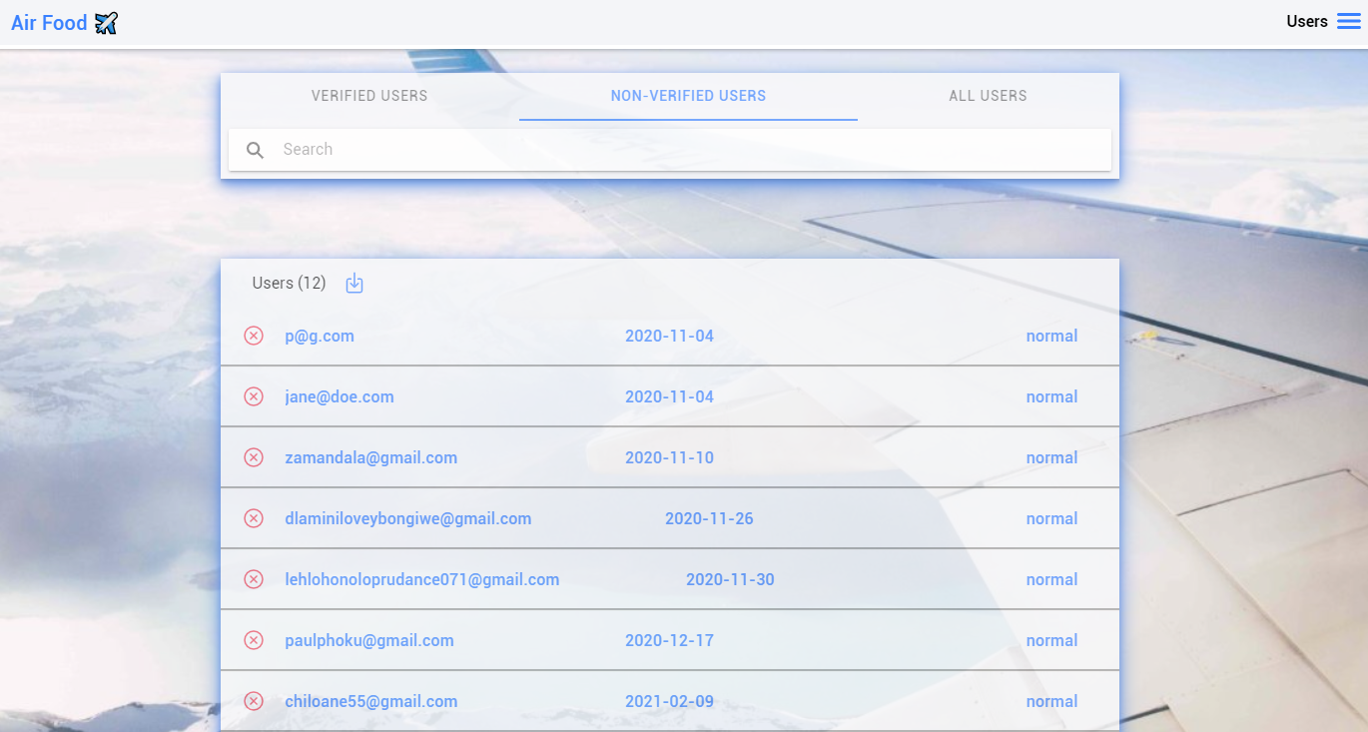

## Verified users

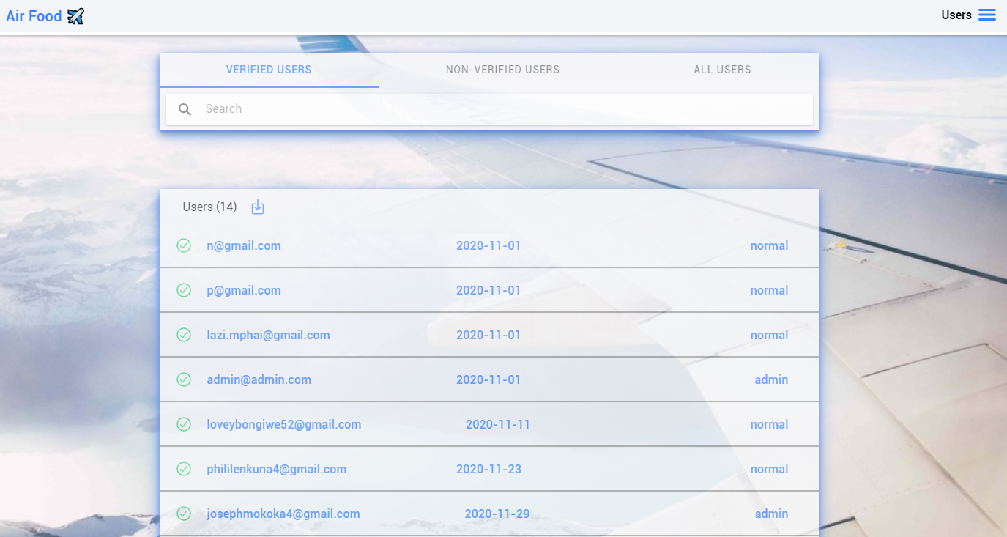

## Filtering by date

Search in a format of year-month-date. e.g “2020-11”

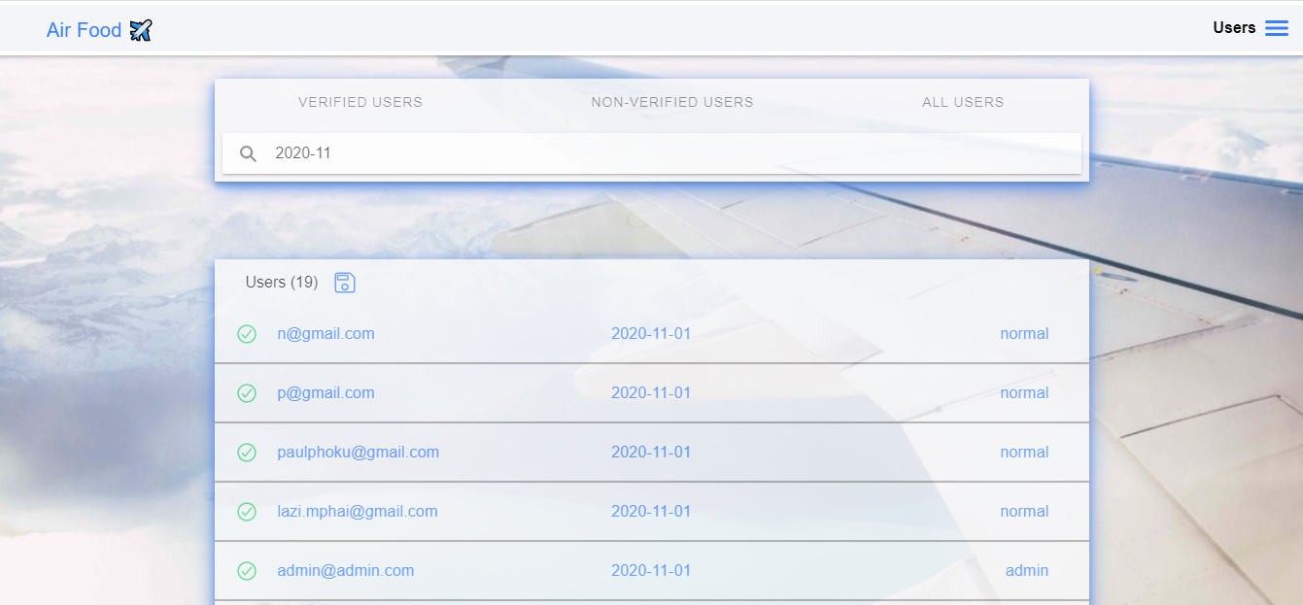

## Filtering by name

Search by name e.g “Paul”

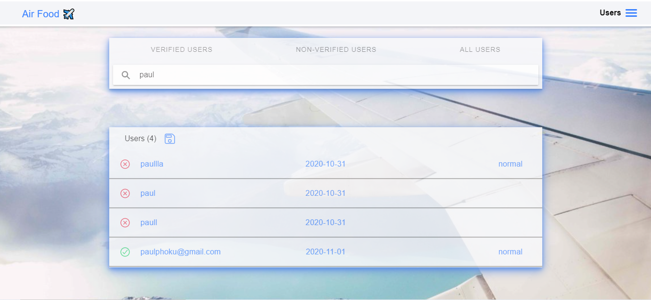

Admin can also download the report in 4 formats which is pdf, json, xlsx and csv.

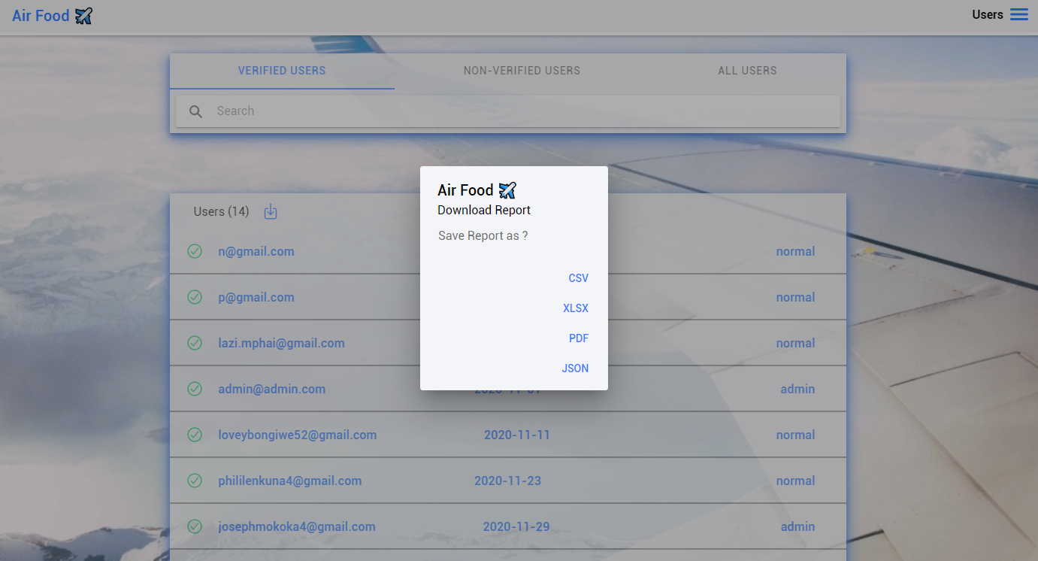

## View flight bookings

* Click on “**MENU**”
* Click on “**Flight** **Bookings**”
* Click on the like-disk icon to download a pdf containing the number of tickets per destination

